# Digital Control: Exercise 1

Xu Fei feixu12@student.hh.se

## , step response.

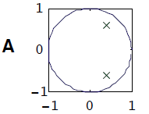From this zero-pole graph, we can see there are two poles in this unit circle, so we can regard the poles as $λ_{1}=\frac{1}{2}+\frac{1}{2}j$ and $λ_{2}=\frac{1}{2}-\frac{1}{2}j$, and then we can regard the constant K as.

So, we can get the equation as:

So, we can transfer it into recursive form:

$$y\left(k\right)=y\left(k-1\right)-\frac{1}{2}y\left(k-2\right)+u(k)$$

$$y\left(0\right)=u\left(0\right)=1$$

$$y\left(1\right)=y(0)+u\left(1\right)=2$$

$$y\left(2\right)=y\left(1\right)-\frac{1}{2}y\left(0\right)+u\left(2\right)=2.5$$

$$y\left(3\right)=y\left(2\right)-\frac{1}{2}y\left(1\right)+u\left(3\right)=2.5$$

$$y\left(4\right)=y\left(3\right)-\frac{1}{2}y\left(2\right)+u\left(4\right)=2.25$$

$$y\left(5\right)=y\left(4\right)-\frac{1}{2}y\left(3\right)+u\left(5\right)=2$$

$$⋯$$

We can see all the poles is inside the circle, so the system is stable.

$$y_{∞}=G\left(1\right)=\frac{1}{1-1+\frac{1}{2}}=2$$

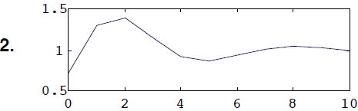This unit step response is similar with number 2 picture.

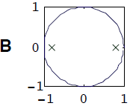From this zero-pole graph, we can see there are two poles in this unit circle, so we can regard the poles as $λ_{1}=\frac{3}{4}$ and $λ_{2}=-\frac{3}{4}$, and then we can regard the constant K as.

So, we can get the equation as:

So, we can transfer it into recursive form:

$$y\left(k\right)=\frac{9}{16}y\left(k-2\right)+u(k)$$

$$y\left(0\right)=u\left(0\right)=1$$

$$y\left(1\right)=u\left(1\right)=1$$

$$y\left(2\right)=\frac{9}{16}y\left(0\right)+u\left(2\right)=1.5625$$

$$y\left(3\right)=\frac{9}{16}y\left(1\right)+u\left(3\right)=1.5625$$

$$y\left(4\right)=\frac{9}{16}y\left(2\right)+u\left(4\right)=1.8789$$

$$y\left(5\right)=\frac{9}{16}y\left(3\right)+u\left(5\right)=1.8789$$

$$⋯$$

We can see all the poles is inside the circle, so the system is stable.

$$y_{∞}=G\left(1\right)=\frac{1}{1-\frac{9}{16}}=\frac{16}{7}$$

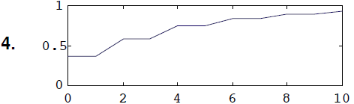This unit step response is similar with number 4 picture.

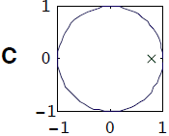

From this zero-pole graph, we can see there is one pole in this unit circle, so we can regard the pole as $λ=\frac{3}{4}$, and then we can regard the constant K as.

So, we can get the equation as:

$$y\left(k\right)=\frac{1}{\left(1-\frac{3}{4}q^{-1}\right)}u(k)$$

So, we can transfer it into recursive form:

$$y\left(k\right)=\frac{3}{4}y\left(k-1\right)+u(k)$$

$$y\left(0\right)=u\left(0\right)=1$$

$$y\left(1\right)=\frac{3}{4}y\left(0\right)+u\left(1\right)=1.75$$

$$y\left(2\right)=\frac{3}{4}y\left(1\right)+u\left(2\right)=2.3125$$

$$y\left(3\right)=\frac{3}{4}y\left(2\right)+u\left(3\right)=2.7344$$

$$y\left(4\right)=\frac{3}{4}y\left(3\right)+u\left(4\right)=3.0508$$

$$y\left(5\right)=\frac{3}{4}y\left(4\right)+u\left(5\right)=3.2881$$

$$⋯$$

We can see the pole is inside the circle, so the system is stable.

$$y_{∞}=G\left(1\right)=\frac{1}{1-\frac{3}{4}}=4$$

So, the graph for this is not match. The correct graph for this unit step response should be like:

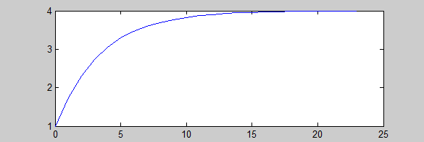

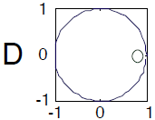From this zero-pole graph, we can see there is one zero in this unit circle, so we can regard the zero as $z=\frac{3}{4}$, and then we can regard the constant K as $K=1$.

So, we can get the equation as:

$$y\left(k\right)=(1-\frac{3}{4}q^{-1})u(k)$$

So, we can transfer it into recursive form:

$$y\left(k\right)=u\left(k\right)-\frac{3}{4}u\left(k-1\right)$$

$$y\left(0\right)=u\left(0\right)-\frac{3}{4}u\left(-1\right)=1-0=1$$

$$y\left(1\right)=u\left(1\right)-\frac{3}{4}u\left(0\right)=0.25$$

$$y\left(2\right)=u\left(2\right)-\frac{3}{4}u\left(1\right)=0.25$$

$$y\left(3\right)=u\left(3\right)-\frac{3}{4}u\left(2\right)=0.25$$

$$y\left(4\right)=u\left(4\right)-\frac{3}{4}u\left(3\right)=0.25$$

$$y\left(5\right)=u\left(5\right)-\frac{3}{4}u\left(4\right)=0.25$$

$$⋯$$

So, $y\left(k\right)=\left\{\begin{aligned}1 k=0 \\ 0.25 k>0\end{aligned}\right.$. The unit step response of this system is like number 3.

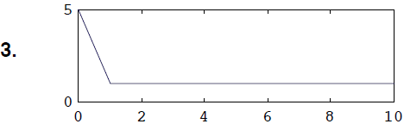

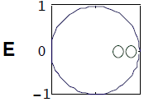From this zero-pole graph, we can see there are two zeros in this unit circle, so we can regard the poles as $z_{1}=\frac{1}{2}$, $z_{2}=\frac{3}{4}$, then we can regard the constant K as $K=1$.

So, we can get the equation as:

$$y\left(k\right)=(1-\frac{3}{4}q^{-1})(1-\frac{1}{2}q^{-1})u(k)$$

$$y\left(k\right)=(1+\frac{3}{8}q^{-2}-{\frac{5}{4}q}^{-1})u(k)$$

So, we can transfer it into recursive form:

$$y\left(k\right)=u\left(k\right)+\frac{3}{8}u\left(k-2\right)-\frac{5}{4}u(k-1)$$

$$y\left(0\right)=u\left(0\right)=1$$

$$y\left(1\right)=u\left(1\right)-\frac{5}{4}u\left(0\right)=-0.25$$

$$y\left(2\right)=u\left(2\right)+\frac{3}{8}u(0)-\frac{5}{4}u\left(1\right)=0.125$$

$$y\left(3\right)=u\left(3\right)+\frac{3}{8}u(1)-\frac{5}{4}u\left(2\right)=0.125$$

$$y\left(4\right)=u\left(4\right)+\frac{3}{8}u(2)-\frac{5}{4}u\left(3\right)=0.125$$

$$y\left(5\right)=u\left(5\right)+\frac{3}{8}u(3)-\frac{5}{4}u\left(4\right)=0.125$$

$$⋯$$

So, $y\left(k\right)=\left\{\begin{aligned}1 k=0 \\ -0.25 k=1 \\ 0.125 k>1\end{aligned}\right.$. The unit step response of this system is like number 3.

So, the graph for this is not match. The correct graph for this unit step response should be like:

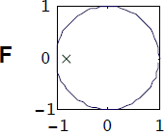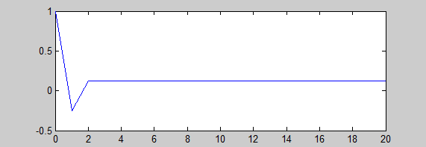

From this zero-pole graph, we can see there is one pole in this unit circle, so we can regard the pole as $λ=-\frac{3}{4}$, and then we can regard the constant K as.

So, we can get the equation as:

$$y\left(k\right)=\frac{1}{\left(1+\frac{3}{4}q^{-1}\right)}u(k)$$

So, we can transfer it into recursive form:

$$y\left(k\right)=-\frac{3}{4}y\left(k-1\right)+u(k)$$

$$y\left(0\right)=u\left(0\right)=1$$

$$y\left(1\right)=-\frac{3}{4}y\left(0\right)+u\left(1\right)=0.25$$

$$y\left(2\right)=-\frac{3}{4}y\left(1\right)+u\left(2\right)=0.8125$$

$$y\left(3\right)=-\frac{3}{4}y\left(2\right)+u\left(3\right)=0.3906$$

$$y\left(4\right)=-\frac{3}{4}y\left(3\right)+u\left(4\right)=0.7070$$

$$y\left(5\right)=-\frac{3}{4}y\left(4\right)+u\left(5\right)=0.4697$$

$$⋯$$

We can see the pole is inside the circle, so the system is stable.

$$y_{∞}=G\left(1\right)=\frac{1}{1+\frac{3}{4}}=\frac{4}{7}$$

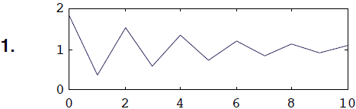The unit step response of this system is like number 1.

## $y\left(k\right)=K\frac{\left(1-z_{1}q^{-1}\right)\left(1-z_{2}q^{-1}\right)⋯\left(1-z_{m}q^{-1}\right)}{\left(1-λ_{1}q^{-1}\right)\left(1-λ_{2}q^{-1}\right)⋯\left(1-λ_{m}q^{-1}\right)}u(k)$, pulse response.

From this zero-pole graph, we can see there are two poles in this unit circle, so we can regard the poles as $λ_{1}=\frac{1}{2}+\frac{1}{2}j$ and $λ_{2}=\frac{1}{2}-\frac{1}{2}j$, and then we can regard the constant K as.

So, we can get the equation as:

$$y\left(k\right)=\frac{1}{\left(1-(\frac{1}{2}+\frac{1}{2}j)q^{-1}\right)\left(1-(\frac{1}{2}-\frac{1}{2}j)q^{-1}\right)}u(k)$$

$$y\left(k\right)=\frac{1}{1-q^{-1}+\frac{1}{2}q^{-2}}u(k)$$

So, we can transfer it into recursive form:

$$y\left(k\right)=y\left(k-1\right)-\frac{1}{2}y\left(k-2\right)+u(k)$$

$$y\left(0\right)=u\left(0\right)=1$$

$$y\left(1\right)=y(0)+u\left(1\right)=1$$

$$y\left(2\right)=y\left(1\right)-\frac{1}{2}y\left(0\right)+u\left(2\right)=0.5$$

$$y\left(3\right)=y\left(2\right)-\frac{1}{2}y\left(1\right)+u\left(3\right)=0$$

$$y\left(4\right)=y\left(3\right)-\frac{1}{2}y\left(2\right)+u\left(4\right)=-0.25$$

$$y\left(5\right)=y\left(4\right)-\frac{1}{2}y\left(3\right)+u\left(5\right)=-0.25$$

$$⋯$$

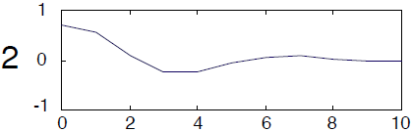The impulse response of this system is like number 2.

From this zero-pole graph, we can see there are two poles in this unit circle, so we can regard the poles as $λ_{1}=\frac{3}{4}$ and $λ_{2}=-\frac{3}{4}$, and then we can regard the constant K as.

So, we can get the equation as:

$$y\left(k\right)=\frac{1}{\left(1-\frac{3}{4}q^{-1}\right)\left(1+\frac{3}{4}q^{-1}\right)}u(k)$$

$$y\left(k\right)=\frac{1}{1-\frac{9}{16}q^{-2}}u(k)$$

So, we can transfer it into recursive form:

$$y\left(k\right)=\frac{9}{16}y\left(k-2\right)+u(k)$$

$$y\left(0\right)=u\left(0\right)=1$$

$$y\left(1\right)=u\left(1\right)=0$$

$$y\left(2\right)=\frac{9}{16}y\left(0\right)+u\left(2\right)=0.5625$$

$$y\left(3\right)=\frac{9}{16}y\left(1\right)+u\left(3\right)=0$$

$$y\left(4\right)=\frac{9}{16}y\left(2\right)+u\left(4\right)=0.3164$$

$$y\left(5\right)=\frac{9}{16}y\left(3\right)+u\left(5\right)=0$$

$$⋯$$

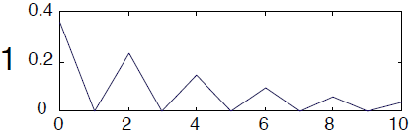The impulse response of this system is like number 1.



From this zero-pole graph, we can see there is one pole in this unit circle, so we can regard the pole as $λ=\frac{3}{4}$, and then we can regard the constant K as $K=1$.

So, we can get the equation as:

$$y\left(k\right)=\frac{1}{\left(1-\frac{3}{4}q^{-1}\right)}u(k)$$

So, we can transfer it into recursive form:

$$y\left(k\right)=\frac{3}{4}y\left(k-1\right)+u(k)$$

$$y\left(0\right)=u\left(0\right)=1$$

$$y\left(1\right)=\frac{3}{4}y\left(0\right)+u\left(1\right)=0.75$$

$$y\left(2\right)=\frac{3}{4}y\left(1\right)+u\left(2\right)=0.5625$$

$$y\left(3\right)=\frac{3}{4}y\left(2\right)+u\left(3\right)=0.4219$$

$$y\left(4\right)=\frac{3}{4}y\left(3\right)+u\left(4\right)=0.3164$$

$$y\left(5\right)=\frac{3}{4}y\left(4\right)+u\left(5\right)=0.2373$$

$$⋯$$

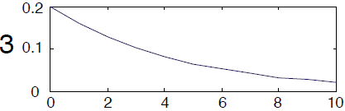The impulse response of this system is like number 3.

From this zero-pole graph, we can see there is one zero in this unit circle, so we can regard the zero as $z=\frac{3}{4}$, and then we can regard the constant K as $K=1$.

So, we can get the equation as:

$$y\left(k\right)=(1-\frac{3}{4}q^{-1})u(k)$$

So, we can transfer it into recursive form:

$$y\left(k\right)=u\left(k\right)-\frac{3}{4}u\left(k-1\right)$$

$$y\left(0\right)=u\left(0\right)-\frac{3}{4}u\left(-1\right)=1-0=1$$

$$y\left(1\right)=u\left(1\right)-\frac{3}{4}u\left(0\right)=-0.75$$

$$y\left(2\right)=u\left(2\right)-\frac{3}{4}u\left(1\right)=0$$

$$y\left(3\right)=u\left(3\right)-\frac{3}{4}u\left(2\right)=0$$

$$y\left(4\right)=u\left(4\right)-\frac{3}{4}u\left(3\right)=0$$

$$y\left(5\right)=u\left(5\right)-\frac{3}{4}u\left(4\right)=0$$

$$⋯$$

So, the graph for this is not match. The correct graph for this impulse response should be like:

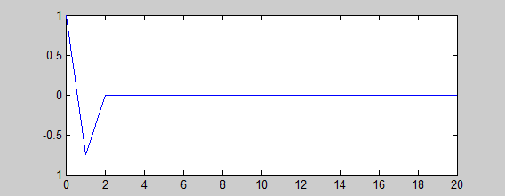

From this zero-pole graph, we can see there are two zeros in this unit circle, so we can regard the poles as $z_{1}=\frac{1}{2}$, $z_{2}=\frac{3}{4}$, then we can regard the constant K as $K=1$.

So, we can get the equation as:

$$y\left(k\right)=(1-\frac{3}{4}q^{-1})(1-\frac{1}{2}q^{-1})u(k)$$

$$y\left(k\right)=(1+\frac{3}{8}q^{-2}-{\frac{5}{4}q}^{-1})u(k)$$

So, we can transfer it into recursive form:

$$y\left(k\right)=u\left(k\right)+\frac{3}{8}u\left(k-2\right)-\frac{5}{4}u(k-1)$$

$$y\left(0\right)=u\left(0\right)=1$$

$$y\left(1\right)=u\left(1\right)-\frac{5}{4}u\left(0\right)=-1.25$$

$$y\left(2\right)=u\left(2\right)+\frac{3}{8}u(0)-\frac{5}{4}u\left(1\right)=0.375$$

$$y\left(3\right)=u\left(3\right)+\frac{3}{8}u(1)-\frac{5}{4}u\left(2\right)=0$$

$$y\left(4\right)=u\left(4\right)+\frac{3}{8}u(2)-\frac{5}{4}u\left(3\right)=0$$

$$y\left(5\right)=u\left(5\right)+\frac{3}{8}u(3)-\frac{5}{4}u\left(4\right)=0$$

$$⋯$$

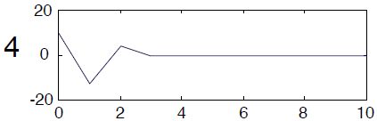The impulse response of this system is like number 4.

From this zero-pole graph, we can see there is one pole in this unit circle, so we can regard the pole as $λ=-\frac{3}{4}$, and then we can regard the constant K as $K=1$.

So, we can get the equation as:

$$y\left(k\right)=\frac{1}{\left(1+\frac{3}{4}q^{-1}\right)}u(k)$$

So, we can transfer it into recursive form:

$$y\left(k\right)=-\frac{3}{4}y\left(k-1\right)+u(k)$$

$$y\left(0\right)=u\left(0\right)=1$$

$$y\left(1\right)=-\frac{3}{4}y\left(0\right)+u\left(1\right)=-0.75$$

$$y\left(2\right)=-\frac{3}{4}y\left(1\right)+u\left(2\right)=0.5625$$

$$y\left(3\right)=-\frac{3}{4}y\left(2\right)+u\left(3\right)=-0.4219$$

$$y\left(4\right)=-\frac{3}{4}y\left(3\right)+u\left(4\right)=0.3164$$

$$y\left(5\right)=-\frac{3}{4}y\left(4\right)+u\left(5\right)=-0.2373$$

$$⋯$$

So, the graph for this is not match. The correct graph for this impulse response should be like:

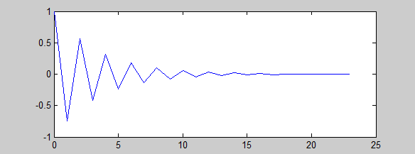

## What are the steady-state (stationary) gain of the following systems?

$y\left(k\right)=\frac{0.1q^{-1}-0.2q^{-2}}{1-{0.1q}^{-1}}u(k)$

We can make the zero-pole graph like this:

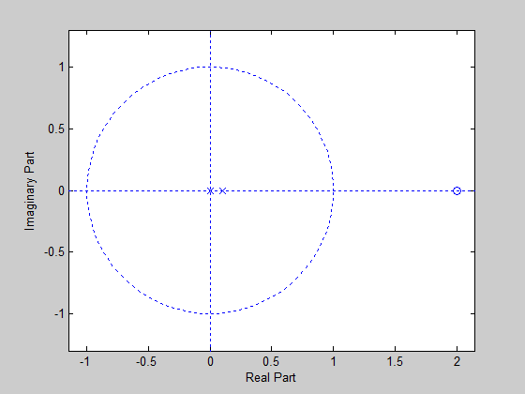

We can see clearly from the graph, that there are two poles, $λ_{1}=0$ and $λ_{2}=1/9$, and the only zero is $z=2$, we can see all the poles are in the unit circle, so the system is stable, $y_{∞}=G\left(1\right)=\frac{0.1-0.2}{1-0.1}=-\frac{1}{9}$

$y\left(k\right)=0.9y\left(k-1\right)+0.1u(k-1)$

We can transfer to differential equation as:

$$y\left(k\right)=\frac{0.1q^{-1}}{1-0.9q^{-1}}u(k)$$

We can make the zero-pole graph like this:

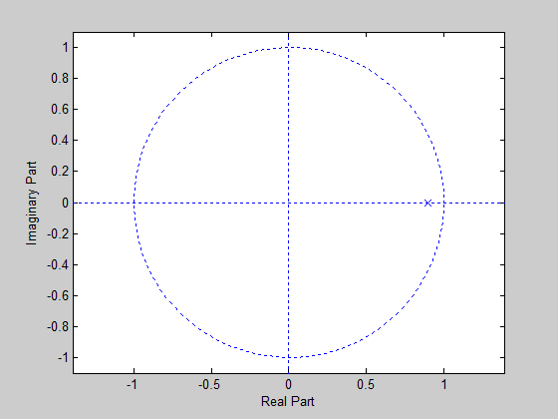

We can see clearly from the graph, that there is one poles, $λ=0.9$, we can see the pole is in the unit circle, so the system is stable, $y_{∞}=G\left(1\right)=\frac{0.1}{1-0.9}=1$

$y\left(k\right)=\frac{-10\left(1-0.1q^{-1}\right)\left(1-0.2q^{-1}\right)}{\left(1-0.9q^{-1}\right)\left(1-0.8q^{-1}\right)}u(k)$

We can make the zero-pole graph like this:

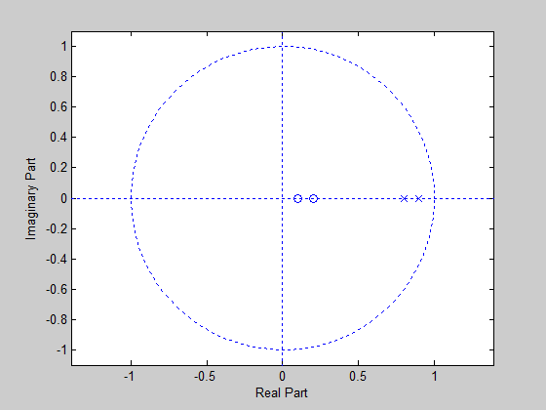

We can see clearly from the graph, that there are two poles, $λ_{1}=0.8$ and $λ_{2}=0.9$, and the only zero is $z_{1}=0.2$ and $z_{2}=0.1$, we can see all the poles are in the unit circle, so the system is stable, $y_{∞}=G\left(1\right)=\frac{-10+3-0.2}{1-1.7+0.72}=-\frac{7.2}{0.02}$ =-360

$y\left(k\right)-2y\left(k-1\right)=2u(k-10)$

We can transfer to differential equation as:

$$y\left(k\right)=\frac{2q^{-10}}{1-2q^{-1}}u(k)$$

We can make the zero-pole graph like this:

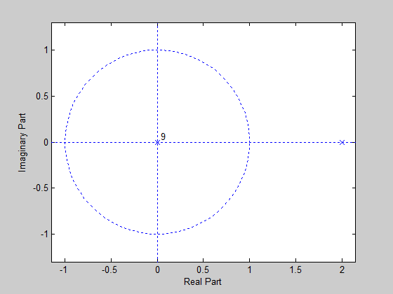

We can see clearly from the graph, that there is one poles, $λ=2$, we can see the pole is not in the unit circle, so the system is not stable, we can’t get any steady-state gain from this system.

## $G\left(q^{-1}\right)=K\frac{(1-z_{1}q^{-1})⋯(1-z_{m}q^{-1})}{(1-λ_{1}q^{-1})⋯(1-λ_{n}q^{-1})}q^{-2}$, step response.

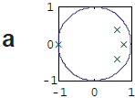From the zero-pole graph, we can see all the four poles are in this unit circle, so the system is stable, and we can assume these four poles as $λ_{1}=-1$, $λ_{2}=\frac{2}{3}+\frac{1}{3}i$, $λ_{3}=\frac{2}{3}-\frac{1}{3}i$ and $λ_{4}=\frac{3}{4}$, and then we regard K as $K=1$.

So, we can get the equation as:

$$G\left(q^{-1}\right)=\frac{1}{(1+q^{-1})(1-(\frac{2}{3}+\frac{1}{3}i)q^{-1})(1-(\frac{2}{3}-\frac{1}{3}i)q^{-1})(1-\frac{3}{4}q^{-1})}q^{-2}$$

$$=>G\left(q^{-1}\right)=\frac{1}{1-\frac{13}{12}q^{-1}-{\frac{19}{36}q}^{-2}+\frac{41}{36}q^{-3}-\frac{5}{12}q^{-4}}$$

Then, we can transfer it to differential equation:

$$y\left(k\right)(1-\frac{13}{12}q^{-1}-{\frac{19}{36}q}^{-2}+\frac{41}{36}q^{-3}-\frac{5}{12}q^{-4})=u(k)q^{-2}$$

$$y\left(k\right)-\frac{13}{12}y\left(k-1\right)-\frac{19}{36}y\left(k-2\right)+\frac{41}{36}y\left(k-3\right)-\frac{5}{12}y\left(k-4\right)=u\left(k-2\right)$$

$$y\left(0\right)=u\left(-2\right)=0$$

$$y\left(1\right)=\frac{13}{12}y\left(0\right)+u\left(-1\right)=0$$

$$y\left(2\right)=\frac{13}{12}y\left(1\right)+\frac{19}{36}y(0)+u\left(0\right)=1$$

$$y\left(3\right)=\frac{13}{12}y\left(2\right)+\frac{19}{36}y\left(1\right)-\frac{41}{36}y\left(0\right)+u\left(1\right)=2.0833$$

$$y\left(4\right)=\frac{13}{12}y\left(3\right)+\frac{19}{36}y\left(2\right)-\frac{41}{36}y\left(1\right)+\frac{5}{12}y\left(0\right)+u\left(2\right)=3.7847$$

$$y\left(5\right)=\frac{13}{12}y\left(4\right)+\frac{19}{36}y\left(3\right)-\frac{41}{36}y\left(2\right)+\frac{5}{12}y\left(1\right)+u\left(3\right)=5.0608$$

$$⋯$$

We can see the pole is inside the circle, so the system is stable.

$$y_{∞}=G\left(1\right)=\frac{1}{1-\frac{13}{12}-\frac{19}{36}+\frac{41}{36}-\frac{5}{12}}=9$$

The step response of this system is like number 5.

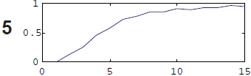

From the zero-pole graph, we can see all the two poles are in this unit circle, so the system is stable, and we can assume these two poles as $λ_{1}=\frac{2}{3}-\frac{1}{3}i$, $λ_{2}=\frac{2}{3}+\frac{1}{3}i$ 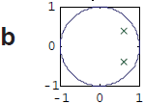, and then we regard K as $K=1$.

So, we can get the equation as:

$$G\left(q^{-1}\right)=\frac{1}{(1-(\frac{2}{3}+\frac{1}{3}i)q^{-1})(1-(\frac{2}{3}-\frac{1}{3}i)q^{-1})}q^{-2}$$

$$=>G\left(q^{-1}\right)=\frac{1}{1-\frac{4}{3}q^{-1}+{\frac{5}{9}q}^{-2}}q^{-2}$$

Then, we can transfer it to differential equation:

$$y\left(k\right)(1-\frac{4}{3}q^{-1}+{\frac{5}{9}q}^{-2})=u(k)q^{-2}$$

$$y\left(k\right)-\frac{4}{3}y\left(k-1\right)+\frac{5}{9}y\left(k-2\right)=u\left(k-2\right)$$

$$y\left(0\right)=u\left(-2\right)=0$$

$$y\left(1\right)=\frac{4}{3}y\left(0\right)+u\left(-1\right)=0$$

$$y\left(2\right)=\frac{4}{3}y\left(1\right)-\frac{5}{9}y(0)+u\left(0\right)=1$$

$$y\left(3\right)=\frac{4}{3}y\left(2\right)-\frac{5}{9}y(1)+u\left(1\right)=2.3333$$

$$y\left(4\right)=\frac{4}{3}y\left(3\right)-\frac{5}{9}y(2)+u\left(2\right)=3.5556$$

$$y\left(5\right)=\frac{4}{3}y\left(4\right)-\frac{5}{9}y(3)+u\left(3\right)=4.4444$$

$$⋯$$

We can see the pole is inside the circle, so the system is stable.

$$y_{∞}=G\left(1\right)=\frac{1}{1-\frac{4}{3}+\frac{5}{9}}=4.5$$

The step response of this system is like number 1.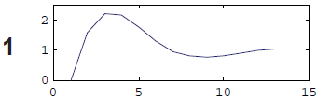

From the zero-pole graph, we can see the pole is in this unit circle, so the 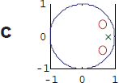system is stable, and we can assume this pole as $λ=\frac{3}{4}$, two zeros as ${ z}_{1}=\frac{2}{3}+\frac{1}{3}i$, $z_{2}=\frac{2}{3}-\frac{1}{3}i$, and then we regard K as $K=1$.

So, we can get the equation as:

$$G\left(q^{-1}\right)=\frac{(1-(\frac{2}{3}+\frac{1}{3}i)q^{-1})(1-(\frac{2}{3}-\frac{1}{3}i)q^{-1})}{1-\frac{3}{4}q^{-1}}q^{-2}$$

$$=>G\left(q^{-1}\right)=\frac{1-\frac{4}{3}q^{-1}+\frac{5}{9}q^{-2}}{1-\frac{3}{4}q^{-1}}q^{-2}$$

Then, we can transfer it to differential equation:

$$y\left(k\right)-\frac{3}{4}y\left(k-1\right)=u\left(k-2\right)-\frac{4}{3}u\left(k-3\right)+\frac{5}{9}u(k-4)$$

$$y\left(0\right)=u\left(-2\right)-\frac{4}{3}u\left(-3\right)+\frac{5}{9}u(-4)=0$$

$$y\left(1\right)=\frac{4}{3}y\left(0\right)+u\left(-1\right)-\frac{4}{3}u\left(-2\right)+\frac{5}{9}u(-3)=0$$

$$y\left(2\right)=\frac{4}{3}y\left(1\right)+u\left(0\right)-\frac{4}{3}u\left(-1\right)+\frac{5}{9}u(-2)=1$$

$$y\left(3\right)=\frac{4}{3}y\left(2\right)+u\left(1\right)-\frac{4}{3}u\left(0\right)+\frac{5}{9}u(-1)=0.4167$$

$$y\left(4\right)=\frac{4}{3}y\left(3\right)+u\left(2\right)-\frac{4}{3}u\left(1\right)+\frac{5}{9}u(0)=0.5347$$

$$y\left(5\right)=\frac{4}{3}y\left(4\right)+u\left(3\right)-\frac{4}{3}u\left(2\right)+\frac{5}{9}u(1)=0.6233$$

$$⋯$$

We can see the pole is inside the circle, so the system is stable.

$$y_{∞}=G\left(1\right)=\frac{1-\frac{4}{3}+\frac{5}{9}}{1-\frac{3}{4}}=\frac{8}{9}$$

The step response of this system is like number 2.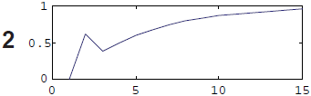

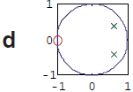From the zero-pole graph, we can see all the poles are in this unit circle, so the system is stable, and we can assume these two poles as, , the zeros as, and then we regard K as .

So, we can get the equation as:

Then, we can transfer it to differential equation:

$$y\left(k\right)-\frac{4}{3}y\left(k-1\right)+\frac{5}{9}y\left(k-2\right)=u\left(k-2\right)+u\left(k-3\right)$$

$$y\left(0\right)=u\left(-2\right)+u\left(-3\right)=0$$

$$y\left(1\right)=\frac{4}{3}y\left(0\right)+u\left(-1\right)+u(-2)=0$$

$$y\left(2\right)=\frac{4}{3}y\left(1\right)-\frac{5}{9}y\left(0\right)+u\left(0\right)+u\left(-1\right)=1$$

$$y\left(3\right)=\frac{4}{3}y\left(2\right)-\frac{5}{9}y\left(1\right)+u\left(1\right)+u\left(0\right)=3.3333$$

$$y\left(4\right)=\frac{4}{3}y\left(3\right)-\frac{5}{9}y\left(2\right)+u\left(2\right)+u\left(1\right)=5.8889$$

$$y\left(5\right)=\frac{4}{3}y\left(4\right)-\frac{5}{9}y\left(3\right)+u\left(3\right)+u\left(2\right)=8$$

$$⋯$$

We can see the pole is inside the circle, so the system is stable.

$$y_{∞}=G\left(1\right)=\frac{1+1}{1-\frac{4}{3}+\frac{5}{9}}=9$$

The step response of this system is like number 1.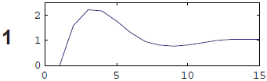

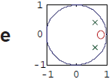From the zero-pole graph, we can see all the poles are in this unit circle, so the system is stable, and we can assume these two poles as, , the zeros as, and then we regard K as .

So, we can get the equation as:

Then, we can transfer it to differential equation:

$$y\left(k\right)-\frac{4}{3}y\left(k-1\right)+\frac{5}{9}y\left(k-2\right)=u\left(k-2\right)-\frac{3}{4}u\left(k-3\right)$$

$$y\left(0\right)=u\left(-2\right)-\frac{3}{4}u\left(-3\right)=0$$

$$y\left(1\right)=\frac{4}{3}y\left(0\right)+u\left(-1\right)-\frac{3}{4}u(-2)=0$$

$$y\left(2\right)=\frac{4}{3}y\left(1\right)-\frac{5}{9}y\left(0\right)+u\left(0\right)-\frac{3}{4}u\left(-1\right)=1$$

$$y\left(3\right)=\frac{4}{3}y\left(2\right)-\frac{5}{9}y\left(1\right)+u\left(1\right)-\frac{3}{4}u\left(0\right)=1.5833$$

$$y\left(4\right)=\frac{4}{3}y\left(3\right)-\frac{5}{9}y\left(2\right)+u\left(2\right)-\frac{3}{4}u\left(1\right)=1.8056$$

$$y\left(5\right)=\frac{4}{3}y\left(4\right)-\frac{5}{9}y\left(3\right)+u\left(3\right)-\frac{3}{4}u\left(2\right)=1.7778$$

$$⋯$$

We can see the pole is inside the circle, so the system is stable.

$$y_{∞}=G\left(1\right)=\frac{1-\frac{3}{4}}{1-\frac{4}{3}+\frac{5}{9}}=\frac{9}{8}$$

The step response of this system is like number 1.

## Group Problems.

For fulfill the requirements, we can build the system function like this:

$$G\left(q^{-1}\right)=K\frac{1+q^{-1}}{(1-λ_{1}q^{-1})(1-λ_{2}q^{-1})}q^{-1}$$

We choose the group 3 which $λ_{1}=0.8+0.3i$, $λ_{2}=0.8-0.3i$, so we can the equation like this: $$G\left(q^{-1}\right)=K\frac{1+q^{-1}}{(1-(0.8+0.3i)q^{-1})(1-(0.8-0.3i)q^{-1})}q^{-1}$$

$$=>G\left(q^{-1}\right)=K\frac{1+q^{-1}}{1-1.6q^{-1}+0.73q^{-2}}q^{-1}$$

We can see $\left|λ_{1}\right|=\left|λ_{2}\right|=0.7616<1$, so the system is stable, from the requirement, we know the steady-state gain is 2.

$$G\left(1\right)= K\frac{1+1}{1-1.6+0.73}=2$$

$$=>K=0.13$$

So, the system is:

$$G\left(q^{-1}\right)=\frac{0.13q^{-1}+{0.13q}^{-2}}{1-1.6q^{-1}+0.73q^{-2}}$$

We can draw the zero-pole graph as:

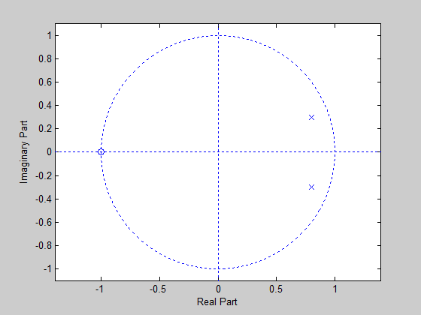

We can transfer the system to the differential equation:

$$y\left(k\right)\left(1-1.6q^{-1}+0.73q^{-2}\right)=u(k)(0.13q^{-1}+0.13q^{-2})$$

$$=>y\left(k\right)-1.6y\left(k-1\right)+0.73y\left(k-2\right)=0.13u\left(k-1\right)+0.13u(k-2)$$

Here, we use step response, $u(k)\left\{\begin{aligned}1 k≥0 \\ 0 k<0\end{aligned}\right.$

$$y\left(0\right)=0.13u\left(-1\right)+0.13u\left(-2\right)=0$$

$$y\left(1\right)=0.13u\left(0\right)+0.13u\left(-1\right)+1.6y(0)=0.13$$

$$y\left(2\right)=0.13u\left(1\right)+0.13u\left(0\right)+1.6y\left(1\right)-0.73y(0)=0.468$$

$$y\left(3\right)=0.13u\left(2\right)+0.13u\left(1\right)+1.6y\left(2\right)-0.73y(1)=0.9139$$

$$y\left(4\right)=0.13u\left(3\right)+0.13u\left(2\right)+1.6y\left(3\right)-0.73y(2)=1.3806$$

$$y\left(5\right)=0.13u\left(4\right)+0.13u\left(3\right)+1.6y\left(4\right)-0.73y(3)=1.8018$$

$$y\left(6\right)=0.13u\left(5\right)+0.13u\left(4\right)+1.6y\left(5\right)-0.73y(4)=2.1351$$

$$y\left(7\right)=0.13u\left(6\right)+0.13u\left(5\right)+1.6y\left(6\right)-0.73y(5)=2.3608$$

$$y\left(8\right)=0.13u\left(7\right)+0.13u\left(6\right)+1.6y\left(7\right)-0.73y(6)=2.4786$$

$$y\left(9\right)=0.13u\left(8\right)+0.13u\left(7\right)+1.6y\left(8\right)-0.73y(7)=2.5025$$

$$y\left(10\right)=0.13u\left(9\right)+0.13u\left(8\right)+1.6y\left(9\right)-0.73y(8)=2.4545$$

$$⋯$$

Here’s the step response:

